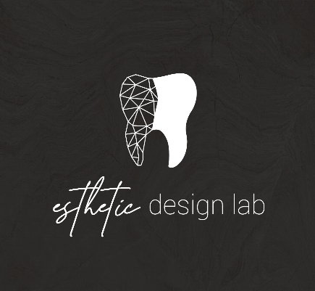
How to add Esthetic Design Dental Lab to Carestream Scanners

- Visit Carestream Connect on your scanner
- Search for Esthetic Design Lab
- Add Esthetic Design Lab
- Select Esthetic Design Lab when submitting scans or raw .STL files

Please let us know if you experience any issues when sending us cases, we will help along the way.

