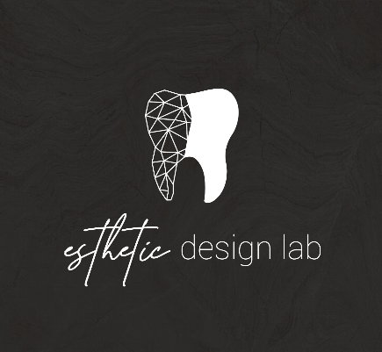
How to add Esthetic Design Dental Lab to 3Shape Trios Scanners
- On the Upper Left Click the More Tab 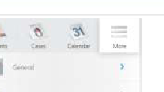
- Click Connections
- Click Labs
- Select Add- For the Lab you wish to connect search the lab by either Lab name or Email. (Office@estheticdesignlab.com)
- The lab will pop up, select request to connect. Contact Esthetic Design Lab (904)456-8570 and ask for the lab to accept the request
- Refresh the page and the lab should appear on your scanner

Now you will be able to see the lab on the send to page when starting a lab case.

Please let us know if you experience any issues when sending us cases, we will help along the way.

